Data structures and algorithms -2

**Name: Girish S Roll No.: AM.EN.U4AIE22044**

--------------------------------------------------------------------------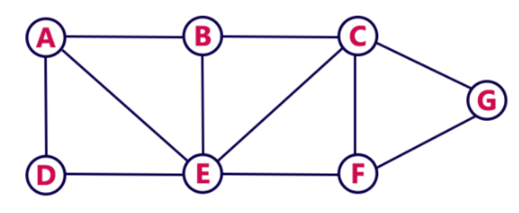



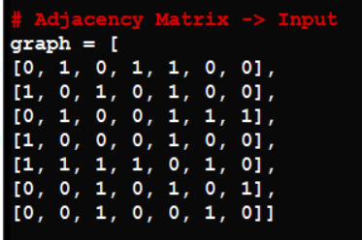

1. **Perform Breadth First Search Algorithm on the given Graph using Adjacency matrix or Adjacency list**

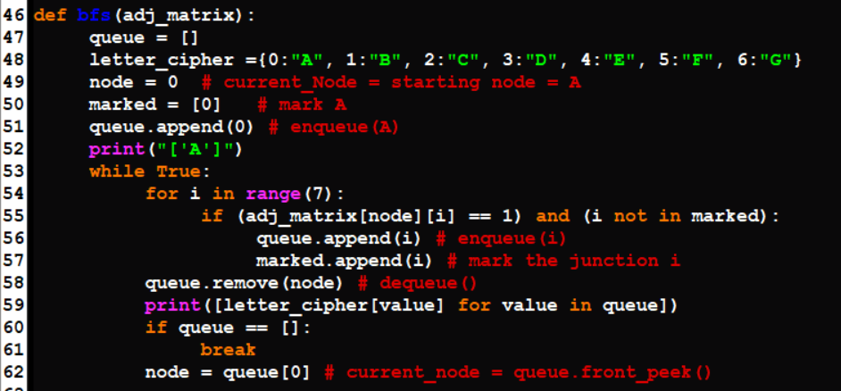

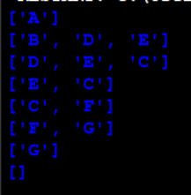

1. **Perform Depth First Search Algorithm on the given Graph using Adjacency matrix or Adjacency list**

